CS 340 Project 2
Jennifer Geurian
Overview
This is an interactive dashboard that uses MongoDB, Python and Dash. It allows users to see records of animals in Austin Animal Center database and filter them based on different rescue categories. Selecting a new filter updates datatable, map, and chart.

This project required interactive filter options, data table that updates with each filter, map showing where animal is located, a chart with breed information based on filtered results, the logo for Grazioso Salvare and my unique identifier.
Screenshots included are Starting dashboard:
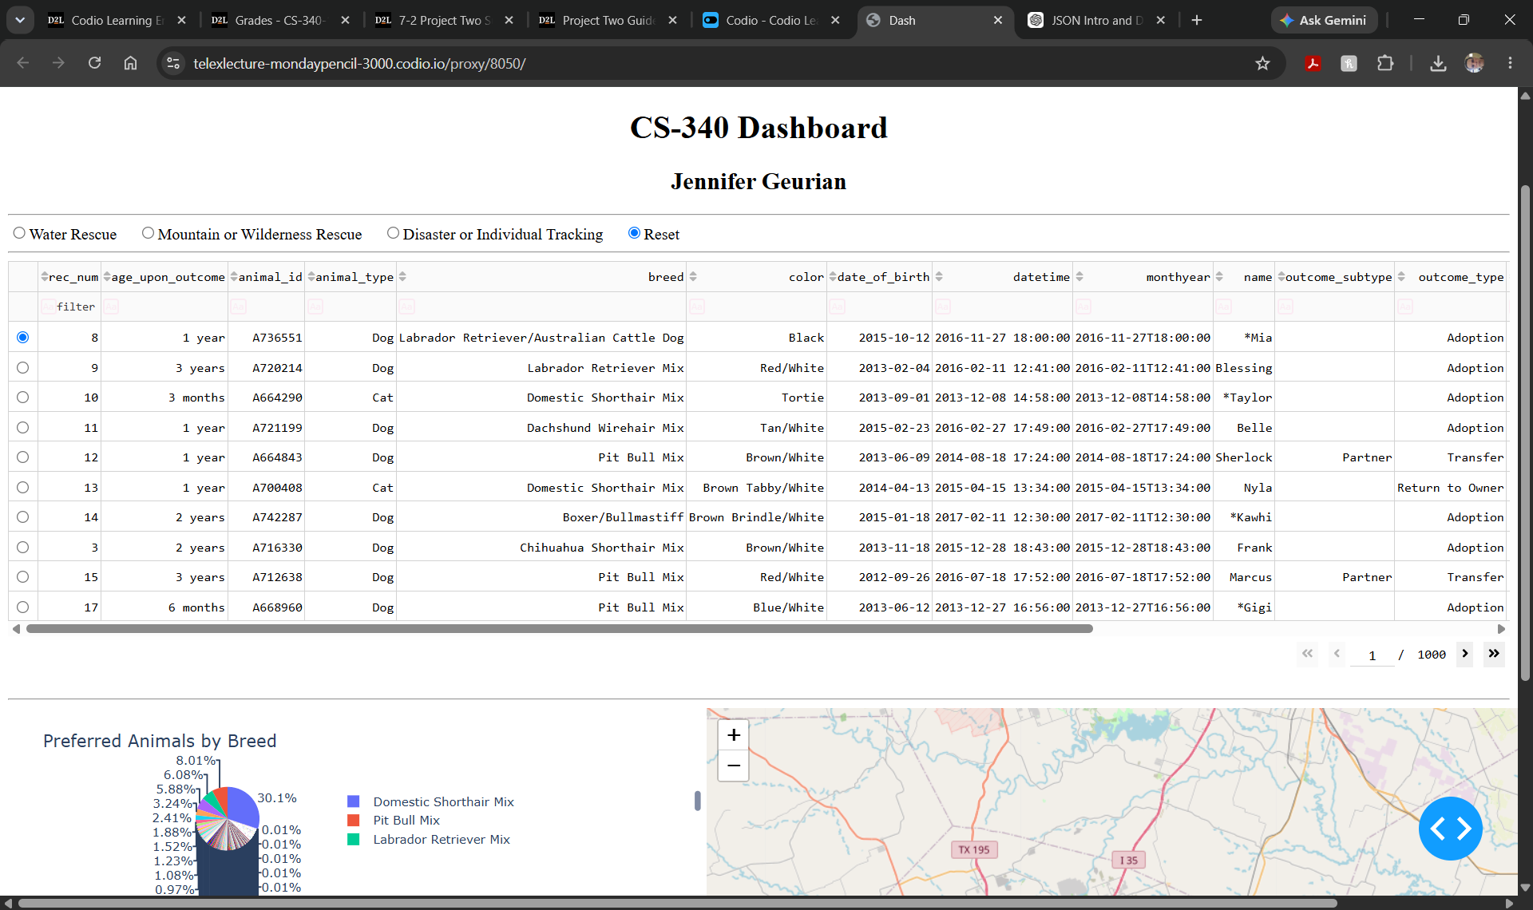
Water rescue filter:

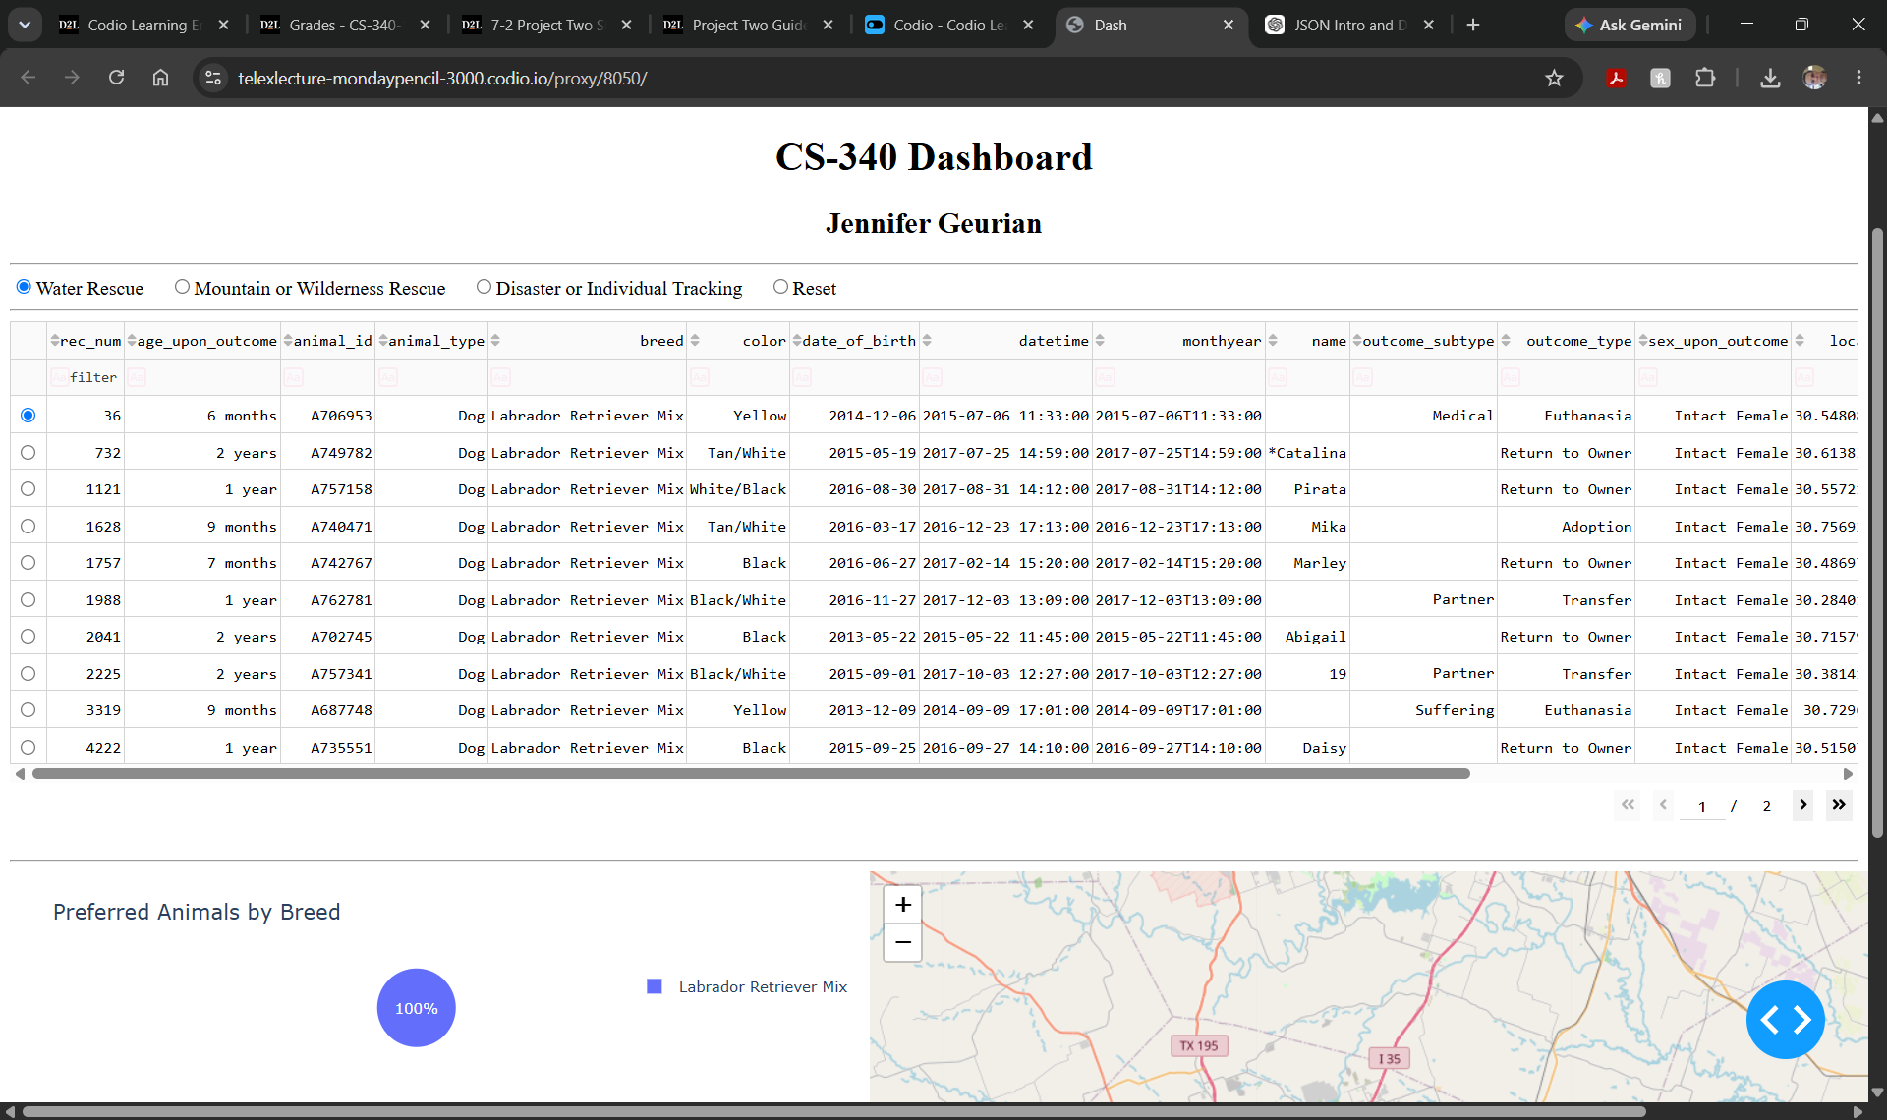
Mountain wilderness rescue:
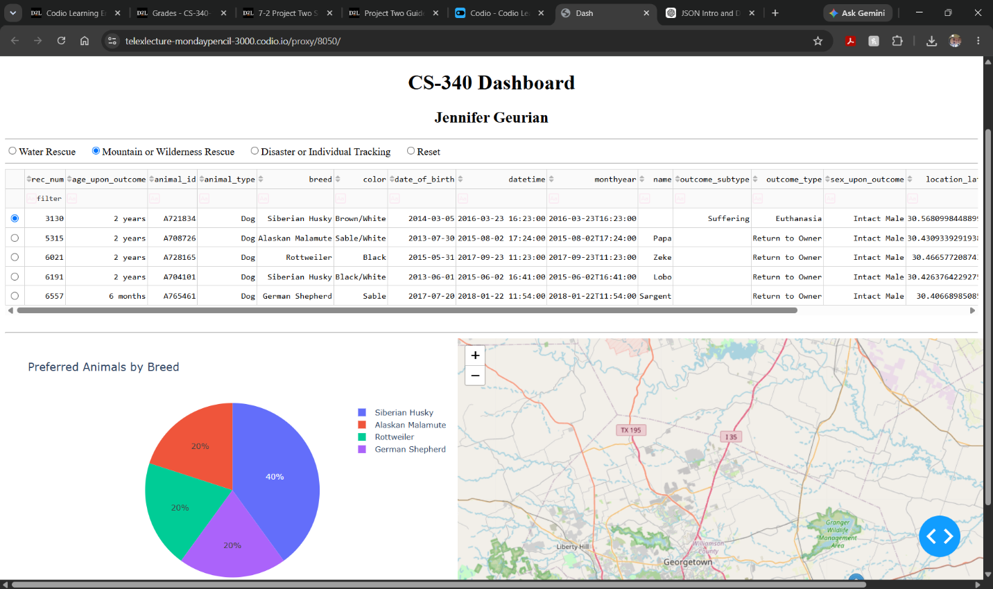

Disaster individual tracking:
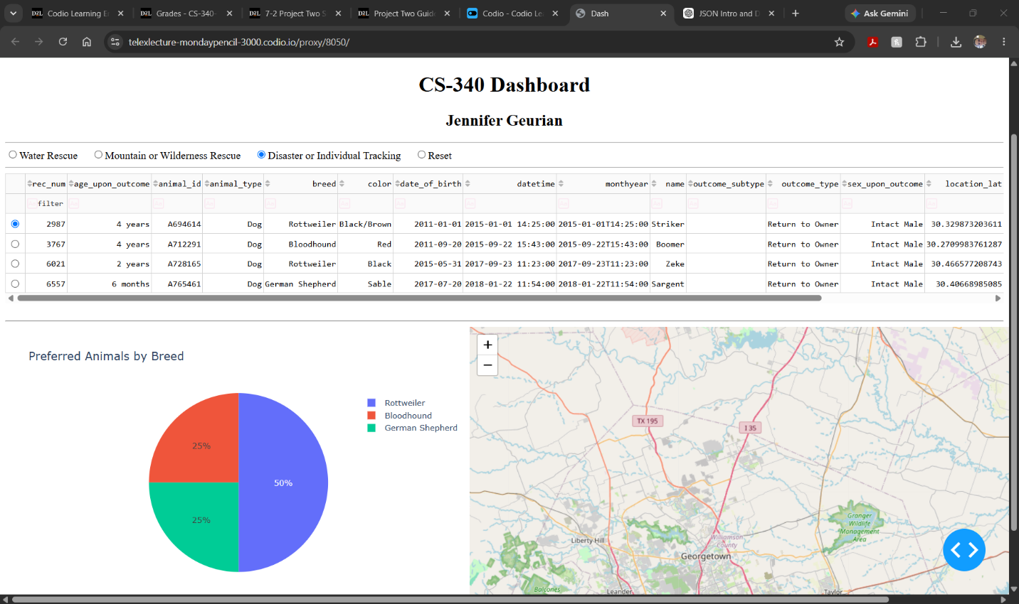

Reset filter:
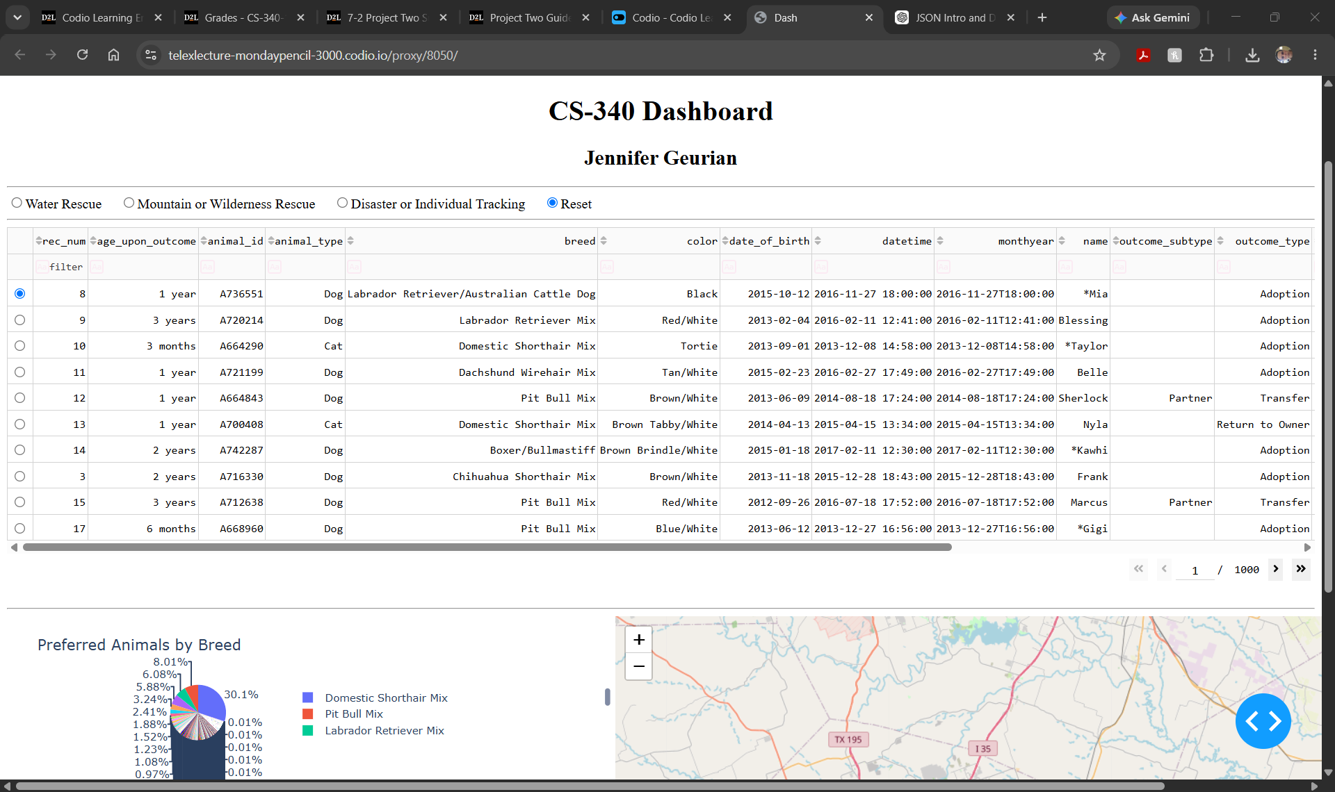

Tools Used:
MongoDB was used to store the database information.
Python was used for the CRUd module, database querries, and dashboard.
PyMongo was used to connect python and MongoDB.
Dash was used for the web dashboard.

